|  |  |  |
| --- | --- | --- |
| OR-GATE | | |
| **W1** | **W2** | **T** |
| 0.5 | 0.5 | 0.5 |
|  |  |  |
| **A** | **B** | **Out** |
| 0 | 0 | 0 |
| 1 | 0 | 1 |
| 0 | 1 | 1 |
| 1 | 1 | 1 |

|  |  |  |
| --- | --- | --- |
| XOR-GATE | | |
| **W1** | **W2** | **T** |
| - | - | - |
|  |  |  |
| **A** | **B** | **Out** |
| 0 | 0 | 0 |
| 1 | 0 | 1 |
| 0 | 1 | 1 |
| 1 | 1 | 0 |

|  |  |  |
| --- | --- | --- |
| NOR-GATE | | |
| **W1** | **W2** | **T** |
| -0.5 | -0.5 | 0 |
|  |  |  |
| **A** | **B** | **Out** |
| 0 | 0 | 1 |
| 1 | 0 | 0 |
| 0 | 1 | 0 |
| 1 | 1 | 0 |

|  |  |  |
| --- | --- | --- |
| NAND-GATE | | |
| **W1** | **W2** | **T** |
| -0.5 | -0.5 | -0.5 |
|  |  |  |
| **A** | **B** | **Out** |
| 0 | 0 | 1 |
| 1 | 0 | 1 |
| 0 | 1 | 1 |
| 1 | 1 | 0 |

|  |  |  |
| --- | --- | --- |
| AND-GATE | | |
| **W1** | **W2** | **T** |
| 0.5 | 0.5 | 1 |
|  |  |  |
| **A** | **B** | **Out** |
| 0 | 0 | 0 |
| 1 | 0 | 0 |
| 0 | 1 | 0 |
| 1 | 1 | 1 |

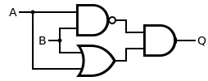

Figure - XOR Poort

Figure - Half Adder

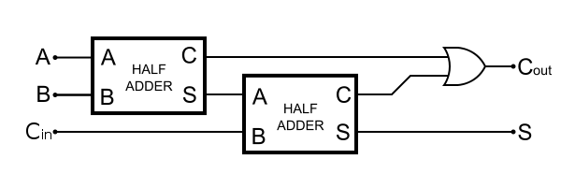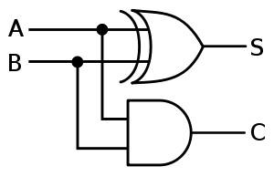

Figure - Full Adder